Steps to a Add New Article to Publication\Subscription without running a Full Snapshot--UpSkill 2020.

Hope you have setup Transactional Replication in your SQL environment. Maybe you have a need to add a new table/article to your existing publication but can't afford the time it takes to create a full new snapshot.

**Here is the Step-by-step process to do that.**

Here we will use a Sample Database **UpSkill2020** for this practice session.

Recently, the *tables: Alpha, Beta* tables are replicated from Publisher to Subscriber.

Now we will add new tables: **Weapon** & **Delta** to be replicated from **Publisher** to **Subscriber**.

**Setup - Test DB Replication Environment**

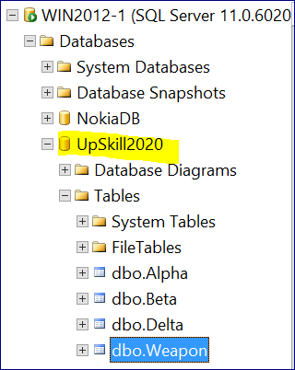

First, Let’s go and see what happens if we just go and add these new 2 tables to the existing publication articles.

Let's add the 1st table: **Weapon**.

Right click on the publication, go to articles and untick the option to only show included articles.

We are going to tick the **Weapon** table and then click OK. This is shown below.

**Full Snapshot Example**

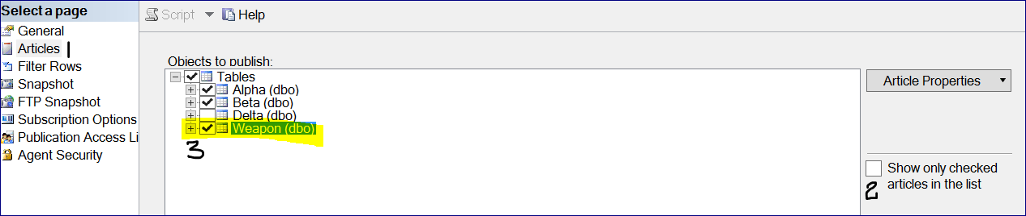

Now, right click on the Publication: “**UpSkill2020_TransPub”**.

Go to "**View Snapshot Agent Status**" and start the snapshot agent. If we open Replication Monitor, we will see the following:

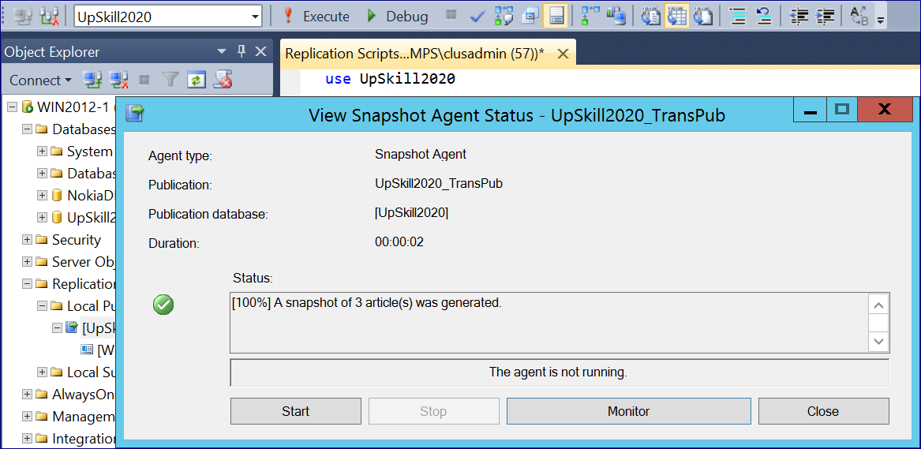

Goto Replication Monitor. Under “All Subscriptions” Right Click on Subscription and click on **VIEW Details**.

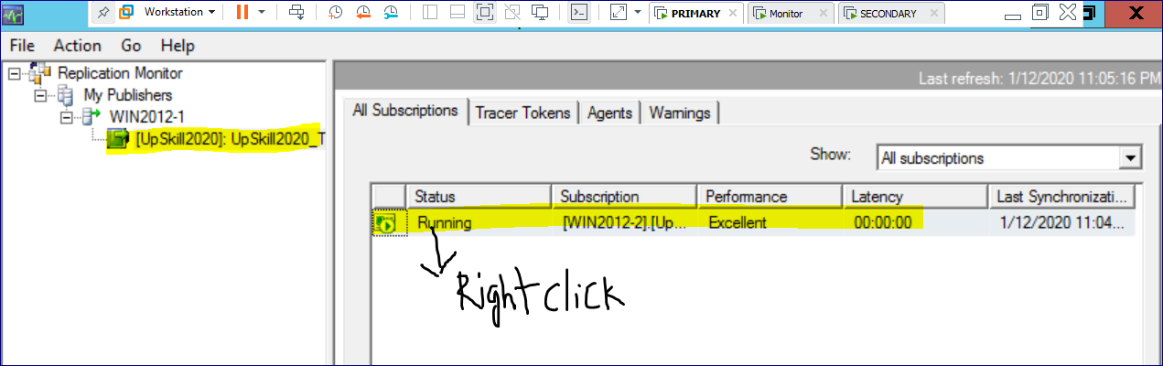

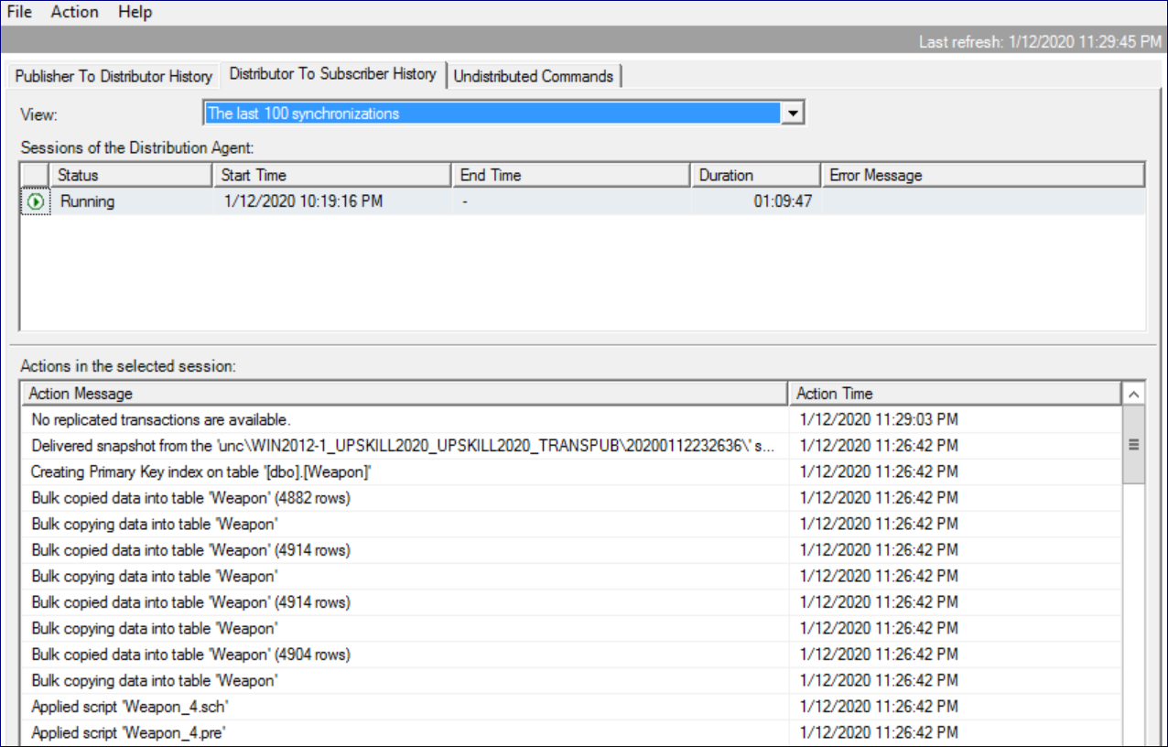

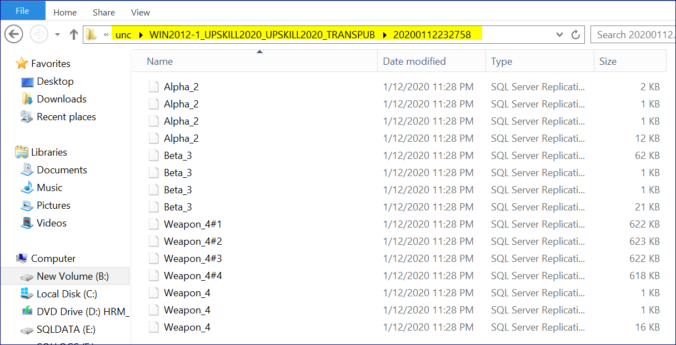

* Watch closely at the above screenshot.
* Here we observed that only the **Weapon** data has been applied to the subscription, which can be seen in Replication Monitor.
* However, in above given Snapshot Agent Monitor screenshot it clearly shows that a snapshot of 3 articles was generated.
* And if we look into our snapshot folder, we see that all 3 articles are there & these files are bcp files and contain the table data.
* Advantage: Even though all the 3 articles were part of the snapshot, only the **Weapon** table is pushed over to the subscriber.
* If we have a local snapshot folder, this isn't a bad solution. But if our snapshot folder is on a remote shared path\drive then we are potentially going to push a lot of data over the network to the subscriber which is a bad solution.

Let's go ahead and fix this so that the full snapshot is not at all necessary.

**Step 1: Update the required Publication properties as follows on Publisher SQL Server.**

All we have to do is to disable 2 publication properties: ***allow_anonymous*** and ***immediate_sync***. Here's how:

**Use Upskill2020 – Put here the publication database name here.**

exec sp_changepublication

@publication=N'Upskill2020_Transpub' -- Mention your publication name here

, @property=N'allow_anonymous'

, @value='false';

go

exec sp_changepublication

@publication=N' Upskill2020_Transpub' -- Mention your publication name here

, @property=N'immediate_sync'

, @value='false';

go

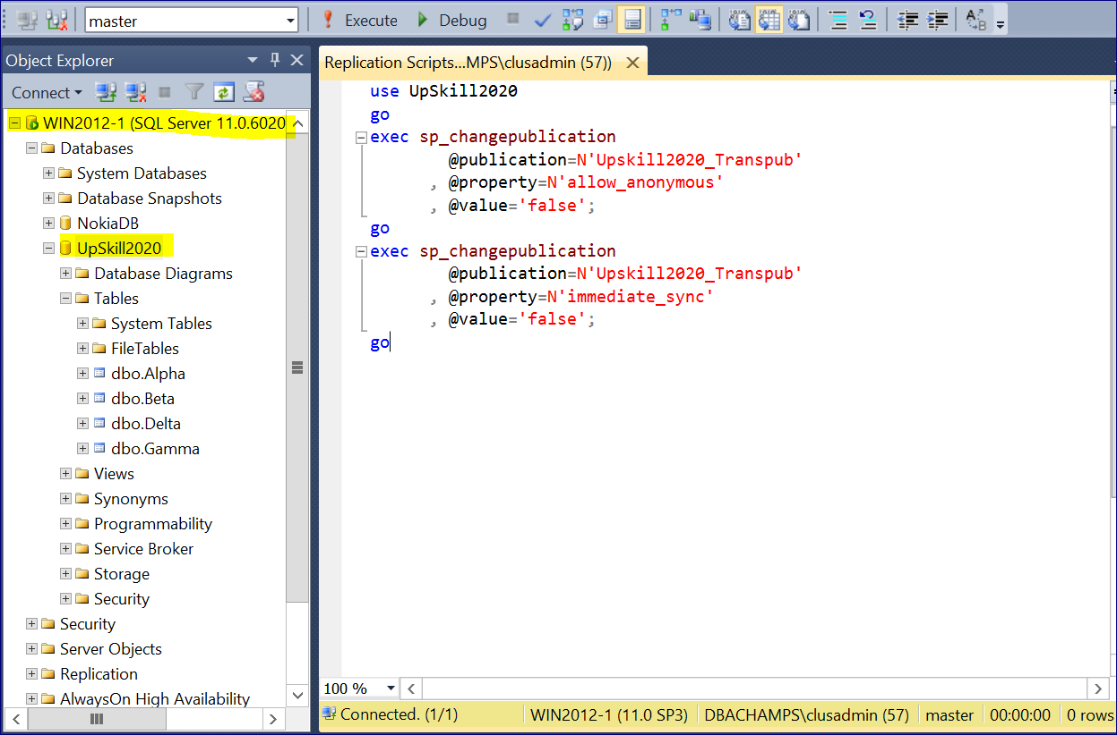

**Step 2: Add your required new articles on existing Publication.**

Now go back to the properties of the publication and add in new required articles.

This time, we will add the table **DELTA**. This is the same as the procedure shown above for adding the **Weapon** table.

**Step 3: Start the Snapshot Agent of the Publication (of which new articles where recently added).**

* Post adding new articles, Right click on the Publication & Select "View Snapshot Agent Status" and start the snapshot agent.
* Load the Replication Monitor and head to our snapshot folder. We will see here a very different scenario this time.
* There is only one table: **DELTA** in the snapshot folder.

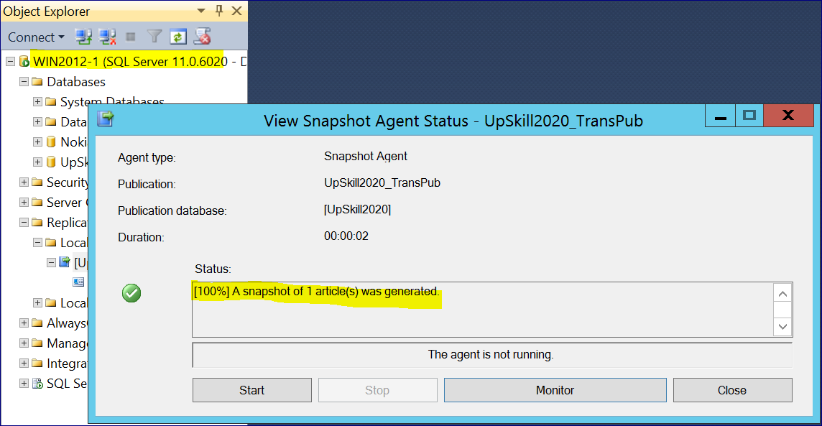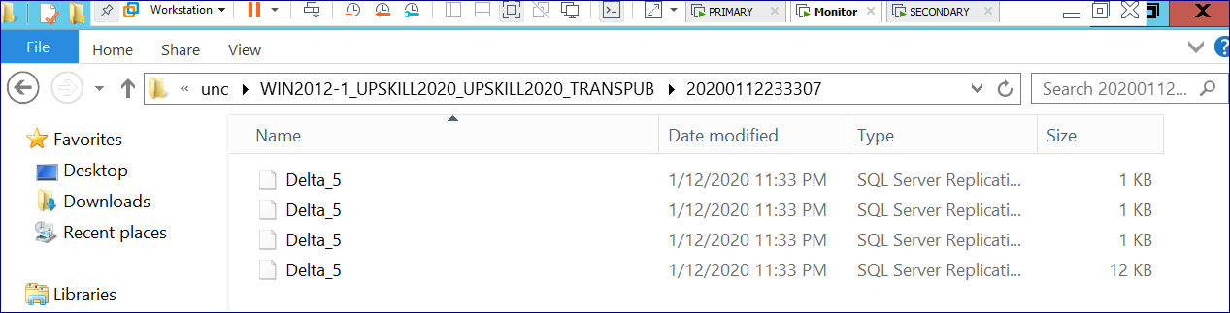

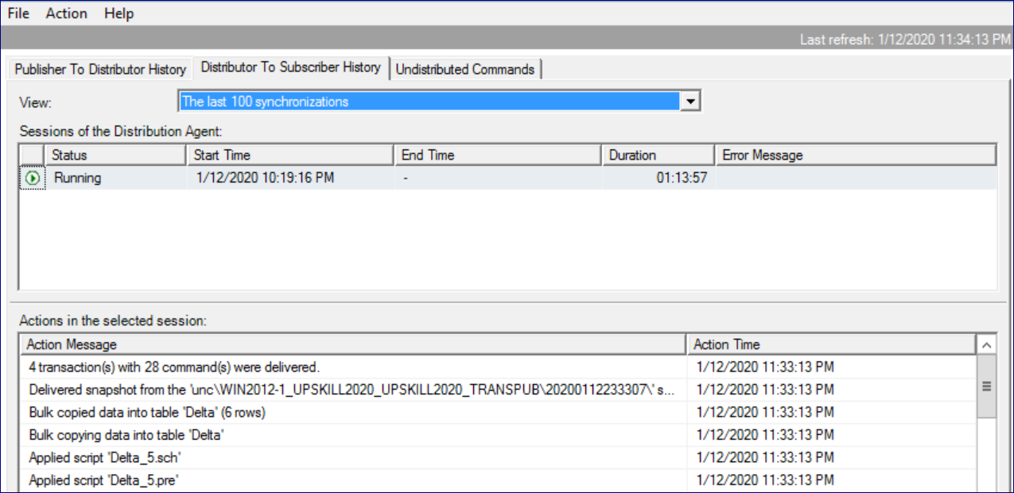

**Step 4: Now verify that new article is replicated to subscription database on Subscriber Server.**

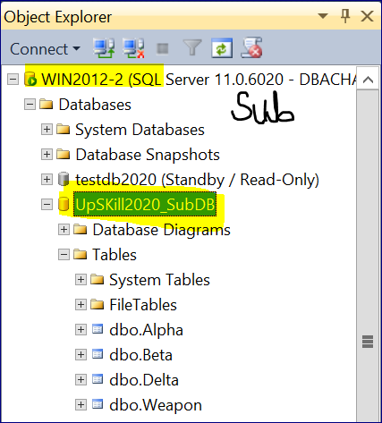

**Upskill 2020   
(IT Freshers & Experienced)**

Dear Connections,

This is Praveen here (Sr SQL Server DBA) with 10 plus years’ experience in Core SQL Server Administration.

I'm from Hyderabad (India) & have planned an Online program named "**UPSKILL 2020**" for both IT Freshers & Experienced.

Please find more details/benefits from this program.

1. Get Mentorship on DBA Skillset (SQL Server, MYSQL, Oracle, MongoDB, etc) & Cloud (Azure, AWS & Google) over Zoom Meetings.

2. Get Mentorship on Development Skillset (SQL Sever, MSBI, Power-BI, Java, PHP, etc) & Testing (Automation & Manual) over Zoom meetings.

3. Get e-books, pdf files, FAQ's, SOP's, KB Articles, Practice Dumps to help you in improving your respective skill set.

4. Get assessed on every 7, 14, 21, 30 days from the respective technology mentors over Zoom Meetings.

5. Get 24x7x365 access to our Self Learning Online Video Account.

6. Get reviewed on your learnings & assignments on weekly basis by the respective Technology mentors.

7. Get Mock Interview calls on respective technologies on weekly basis & get complete reviews to improve your skillset.

8. Get assistance from mentors for free till you get the job.

9. This entire program is charged at just Rs **2500/$50 (USD)** for lifetime with no expiry & with a full refund if not found worthy at any time.

10. For more details, please contact me @ 91-819-729-3434 (or) praveen.madupu@gmail.com

WhatsApp @ 91-98661-30093 || Google Pay: 91-8197293434 || PayPal: Praveen.Madupu@gmail.com